- Answer the following limit questions showing full justification.
- Create three limits that all have the form of but produce the answers of , 0, and.

- Kyle is trying to answer the following questions and presents the following work to his professor. Why is Kyle’s work incorrect or insufficient to justify his answer?
- .
- .
- Evaluate the limit providing full justification.

- Determine the horizontal and vertical asymptotes to
- Determine the horizontal and vertical asymptotes to .

Recall the limit laws that we discussed in class.
Theorem: Suppose that c is a constant, n is a positive integer and the limits and exist. Then,

- TRUE or FALSE: If neither nor exists, then must not exist. If the statement is true provide a justification demonstrating that it is true. If the statement is false, provide a counter-example that shows the statement is false.

- TRUE or FALSE: If does not exist then it must be the case that either or do not exist. If the statement is true provide a justification demonstrating that it is true. If the statement is false, provide a counter-example that shows the statement is false.

Now we turn to some more atypical questions to challenge or understanding of the topics of this chapter thus far.

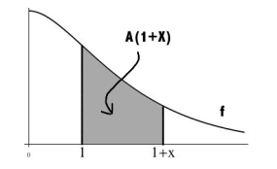
- The function f is continuous and decreasing on . Define to be the area from 1 to under the graph of f and above the x-axis (as shown in the picture below).

Compute . Hint:
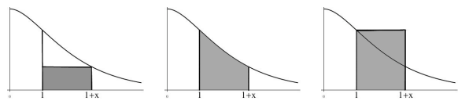

- Is there a value of a such that exists?

